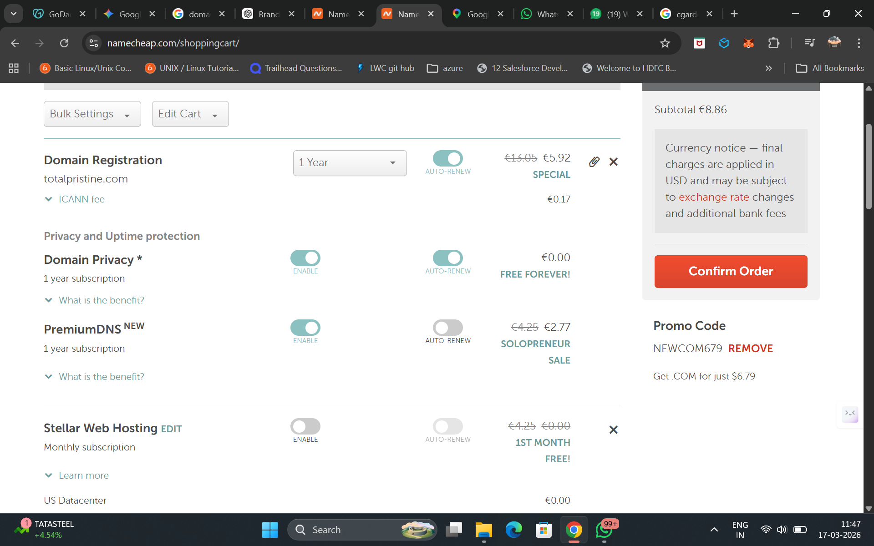

Email: totalpristine.info@gmail.com
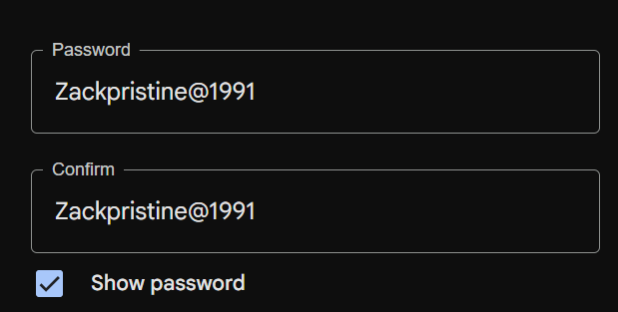

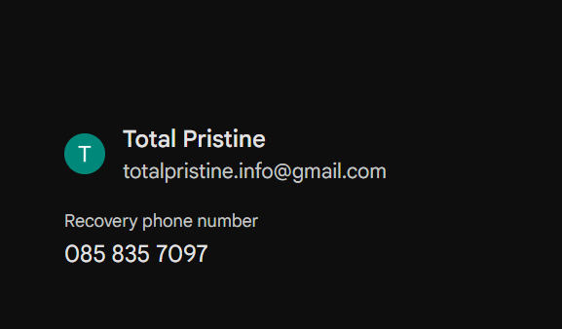

Nmae cheap account details:
Username: totalpristine1991
Password: Zack@1991

